Many Christians Fought Against Hitler
Paul G. Humber, 2017

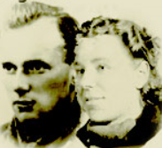
There was much Christian Resistance to Hitler in many, many places, but let me begin with Diet Eman of Holland, a Bible-believing Christian. She never married her fiancé (seen in the photo with her to the left). The image to the right is of her 30+ years later. She suffered greatly in concentration camps. Puss oozed from her face. Hopes of eventually marrying her fiancé died. She travelled all over her country to save the lives of and care for many Jews, and she is officially recognized by the State of Israel as receiving the "Righteous Among the Nations Award," an award given to Gentiles who had risked their lives for the Jewish people. She resisted Hitler’s survival-of-the fittest mania. Believing Jews to be lower (on evolution’s supposed scale), Hitler tried (in his mind) to advance “progress” by weeding out inferior (in his mind) peoples. Jesus said that we would know evil people by their fruit, and slaughtering of Jews and Christian Nazi-resisters is rotten fruit. [Russia’s Stalin and America’s Sanger, who also bought into evolutionary bigotry, also offered rotten fruit; millions have died under them as well.]

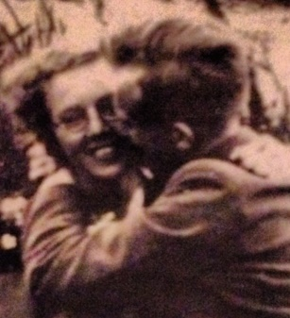
First, let’s talk about this beautiful young Christian woman named Diet Eman. She cared for many Jews is Holland in 1944 and 1945, when she was around 23 and 24 years old. A vibrant young woman, she wrote not only about puss oozing from her face but also about diarrhea filling her pants, feeding a starving dog, and her broken heart. On p137 of her book, Things We Couldn’t Say, she said, “They thought we were stupid to do it, of course; in fact, it was beyond their comprehension that we would risk so much for Jews.” She wrote, “All of the Jews we had hidden with Christian farm families made it—every single one. One of them, Albert, whom we had placed with Ab’s brother, a simple, good Dutch farmer who read from the Bible every day, excepted Jesus as the promised messiah” (p368).

Also, in her book, she wrote, “None of the people we hid really know what to say to me when it was over. They had come through it, but I had lost my true love. The war was very difficult for them—and for me” (p368). Her “true love” had written his last message to her on toilet paper. She wrote, “Then he addressed it to me at my parents’ address in The Hague and threw it from the railroad car. It must have fallen along the tracks. Someone, somehow, picked up that fragile, tiny piece of correspondence, and later—I don’t remember exactly when—I received it” (372).

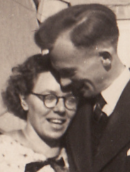
A few pages earlier, she had written, “Such an impression is the image of Hein Sietsma [her fiancé]—a joyful Christian who loved life so much but was still willing to give it to the great, good, and holy cause” (p370). She added, “I could then accept his death, because I knew from others—not all of them Christians either—that Hein, even in his greatest misery, had been a light in their darkness” (p371).

Her book ended on p374 with these words, quoting Jesus, “He told us, ‘Lo, I am with you always.’”

There is also a Postscript which refers to many people mentioned in her resistance efforts, including Corey ten Boom, “I succeeded quite well till Corey ten Boom came to our town in 1978 and spoke about her experiences and God’s faithfulness” (p377).

Except for a poem, she ended the book with Rev 12:11, “They did not love their lives so much as to shrink from death.”

Apparently, there are 5,594 others (just from Netherlands alone) who received the award. Diet was not alone, but there were many others from different countries who have received the award—6,706 from Poland, 3,995 from France, 2,573 from Ukraine, 1,731 from Belgium, etc.

But was Hitler Really an Evolutionary Fanatic?

Hitler said, “Nature is always teaching us ... that she is governed by the principle of selection: that victory is to the strong and the weak must go to the wall. She teaches us that what may seem cruel to us, because it affects us personally or because we have been brought up in ignorance of her laws, is nevertheless often essential if a higher way of life is to be attained. Nature [i.e. Evolution] ... knows nothing of the notion of humanitarianism which signifies that the weak must at all costs be surrounded and preserved even at the expense of the strong. Nature does not see in weakness any extenuating reasons ... on the contrary, weakness calls for condemnation ... War is therefore the unalterable law of the whole of life — the prerequisite for the natural selection of the strong and the precedent for the elimination of the weak. What seems cruel to us is from Nature’s point of view entirely obvious. A people that cannot assert itself must disappear and another must take its place. All creation is subject to this law; no one can avoid it ... Since life on earth began, struggle has been the very essence of existence ...” [Helmut Krausnick and Martin Broszat’s Anatomy of the SS State, published by Paladin, 1970, pp.29-30].

Did Christian Pastors Even In GERMANY Oppose Hitler?

Yes! In The Church's Confession under Hitler, author Arthur Cochrane presented the not sufficiently well-known statement of exiled Albert Einstein, the great physicist, cited by Wilhelm Niemoller in Kampi und Zeugnis der bekennenden Kirche - Struggle and Testimony of the Confessing Church, p.526:
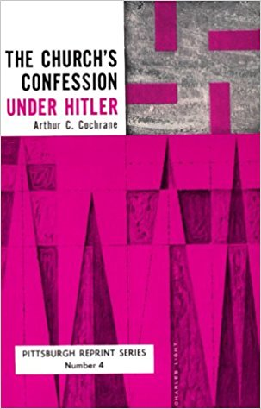
Being a lover of freedom, when the (Nazi) revolution came, I looked to the universities to defend it, knowing that they had always boasted of their devotion to the cause of truth; but no, the universities were immediately silenced. Then I looked to the great editors of the newspapers, whose flaming editorials in days gone by had proclaimed their love of freedom; but they, like the universities, were silenced in a few short weeks...
Only the Church stood squarely across the path of Hitler's campaign for suppressing truth. I never had any special interest in the Church before, but now I feel a great affection and admiration for it because the Church alone has had the courage and persistence to stand for intellectual and moral freedom. I am forced to confess that what I once despised I now praise unreservedly.

Roland H. Bainton offered substantiation:

Some four thousand Protestant ministers, led by Karl Barth and Hans Asmussen, formed the Confessing Church, which at Barmen in 1934 declared that no human Fuhrer could stand above the Word of God. The Confessing Church lost its properties, its seminary was suppressed, its journals were prohibited, and when war came the members of its clergy of military age and not in prison were assigned to positions of greatest danger, while the older leaders were sent to concentration camps. Among them was Martin Niemoller, a Lutheran pastor who after more than half a year in solitary confinement was brought to trial under Hitler's law against "treacherous attacks upon state and party." His refusal to capitulate and his persistent resistance to Nazism made him the symbolic figure of the Protestant opposition until the downfall of the Nazis.

Cochrane had magnified the significance by affirming that "by January 15, 1934, there were 7,036 members" of the pfarrernotbund, Pastor's Emergency League, which was organized by Martin Niemoller, the courageous Berlin pastor. Cochrane added that in "spite of heavy losses and in spite of the imprisonment of its founder on July 1,1937, the League was never dissolved or banned, and it rendered service until as late as Christmas, 1944."

In a memorandum submitted to Hitler on June 4, 1936, the German Evangelical Church questioned whether the Chancellor was trying "to dechristianize the German people." (Hitler had little place in his heart for a religion that worshipped a Jew.) Of even more significance is the statement: “When, within the compass of the National Socialist view of life, an anti-Semitism is forced on the Christian that binds him to hatred of the Jew, the Christian injunction to love one's neighbor still stands, for him, opposed to it.”

The New York Times reported the death of Victor Kugler and credited him as the one who "hid Anne Frank" in Holland. The article describes him as a "Christian" and quotes Charles Wittenberg's words that Kugler "was a man who opened the doors to shelter victims escap(ing) from the Nazi hell at a time when the whole world had closed its doors."

Well, NYT, the whole world did not close its doors. Many Christians opposed Hitler!

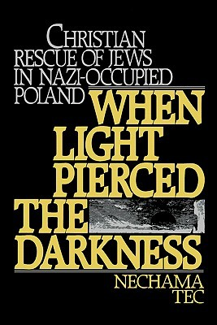
There were Christians in Poland whose hearts went out to Jews. Nechama Tec, a professor of sociology at the University of Connecticut, herself a beneficiary for three years of Christian compassion in Poland, has written a book, When Light Pierced the Darkness. Her thesis was that religion played a very important role in motivating Christians to compassion for the Jews.

In America, William Jennings Bryan, the great American statesman and Christian spokesman, learned "that it was Darwinism that was at the basis of that damnable doctrine that might makes right that had spread over Germany."

Jesus, a Jew, allowed His heart to be broken and His flesh to be torn for the benefit of His enemies. Is it any wonder that a sizable group of Christians, who worship Jesus as God, believe Him to be the Creator, and see each human being as one made in God's image, would find Hitler's philosophy utterly repugnant and seek to follow Jesus by opening their hearts of compassion to save suffering Jews?

Atheists want to condemn Christianity for the Inquisition and Crusades, but much of the Inquisition was Rome against Protestants. Happily, Rome and many Evangelical Protestants today oppose the death-worship-dogma of abortion.

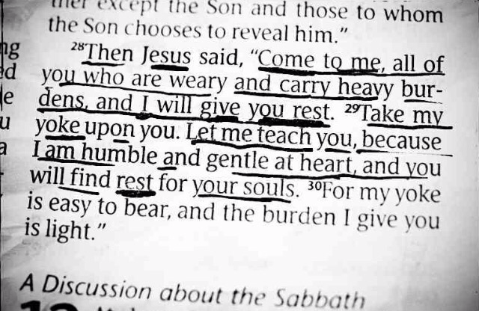
As far as the Crusades are concerned, do we see Christians today holding up heads of Muslims? Or is it more the other way around? Christians are still being crucified.

Solution? Repentance and Faith in the Lord Jesus Christ. He knows all about rejection, but He also said, “Come to Me, all who are weary and heavy-laden, and I will give you rest. Take My yoke upon you and learn from Me, for I am gentle and humble in heart, and you will find rest for your souls. For My yoke is easy and My burden is light.”

Diet found rest in Jesus. I have rest in Him. Do you? Right now is a good time for you to get right with your Creator—the only Savior from sin, self, and hell! Talk to Him in your heart. He made your ear and can heart your heart-cry. He not only went to the cross, but He came alive again three days later! No other person ever did that!

************
Diet on YT, 3.28 https://www.youtube.com/watch?v=_NJasOHexls

As of June 16, 2017, the award has been made to 26,513 people (according to Wikipedia).

